

**OFFICE OF THE PRESIDENT**

**DATE ; June 17, 2020**

**TO : ALL CONCERNED**

**SUBJECT : DATA CONNECTIVITY ALLOWANCE POLICY AND LAPTOP**

**LOAN POLICY**

In order to be of assistance to the teaching and non-teaching staff of the university during this Pandemic, the School Board has approved the following effective immediately:

!. Data Connectivity Allowance Policy

2. Laptop Loan Policy

Thank you for your attention and let us continue to pray for the safety of everyone.

Adelante!

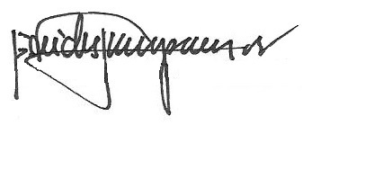

REV. FR. CRISTOPHER C. MASPARA, OAR

President

/bvs

Attachments